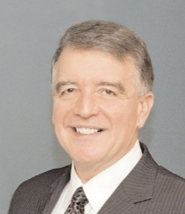
The Lougheed Family & Staff Salute...
Lions Clubs of Zone 47N for hosting
“SERVING HUMBLY WITH HEART”
47th Annual
A 5 Convention 2022

Geoffrey Lougheed
Colette Blais Lougheed
Gerry Lougheed Jr.

